Naval Station Mayport
J-1601000-01
Utilities Points of Demarcation

Electrical System

Definitions
Service - The conductors and equipment for delivering electric energy from the serving utility to the wiring system of the facility served.
Service Equipment - The main control and cutoff equipment, usually consisting of a circuit breaker(s) or switch(es) and fuse(s), and their accessories, connected to the load end of conductors to a building or other structure.
Service Drop - The overhead conductors and last pole or other aerial support, to and including the splices, to the Service Entrance Conductors or Service Lateral.
Service Entrance Conductors - The conductors between the Service Equipment and the point of connection to the Service Drop, typically at the weatherhead, or Service Lateral (sometimes referred to as secondary line), typically at the junction box.
Distribution Switchboard - An enclosure or set of enclosures typically containing a main breaker and multiple feeder breakers serving individual loads or facilities.
Service Lateral - The underground conductors; regardless of voltage class, between the Service Drop and the Service Entrance Conductors; or from a pad mounted transformer or distribution switchboard to the Service Entrance Conductors. Service laterals are sometimes referred to as secondary lines.
Unit Substation - A substation consisting of one or more transformers, an incoming primary section and a transition section (connected to secondary switchgear). The unit substation may be connected to the electrical distribution system of the activity or to the electrical distribution system of one or more facilities.
Point of Demarcation (Service Point) - The point of demarcation or service point is the point of connection between the serving utility and the facility. This is the transition between utility real property and facility real property installed equipment (RPIE). RPIE is defined as an item of equipment that is affixed and built into a facility as an integral part of that facility.
Weatherhead - A weatherproof service drop entry point where overhead power wires enter a building, or where wires transition between overhead and underground cables. At a building the wires enter a conduit, a protective metal pipe, and the weatherhead is a waterproof cap on the end of the conduit that allows the wires to enter without letting in water. Also called a weathercap, service head, service entrance cap, or gooseneck (slang).

Points of Demarcation (Service Points)
Service Drop Demarcation - The point of demarcation (Service Point) is at the load end of the service drop where spliced to the service entrance conductors, typically at the weatherhead.
Service Lateral Demarcation - The point of demarcation (Service Point) is at the connection to the secondary lugs of the transformer or distribution switchboard at the load side of the feeder breakers or at the connection to the service drop.
Unit Substation Demarcation - The point of demarcation (Service Point) for a unit substation with co-located switchgear or remote switchgear feeding multiple facilities is either at the downstream transformer or downstream of the unit substation switchgear. The point of demarcation (Service Point) when the switchgear only serves one facility, is at the connection to the secondary lugs of the transformer.
Electric Meter – Meters are typically RPIE to the electrical distribution system and are only shown for clarity. The location of the meter may vary from facility to facility.
Piers & Dry Docks - The point of demarcation (service point) is at the shore to ship power receptacle. Refer to Drawings E-8 and E-9.
Drawings for Electrical System Points of Demarcation - Drawings depicting examples of Points of Demarcation for the Electrical System can be found below in E-1 to E-9.

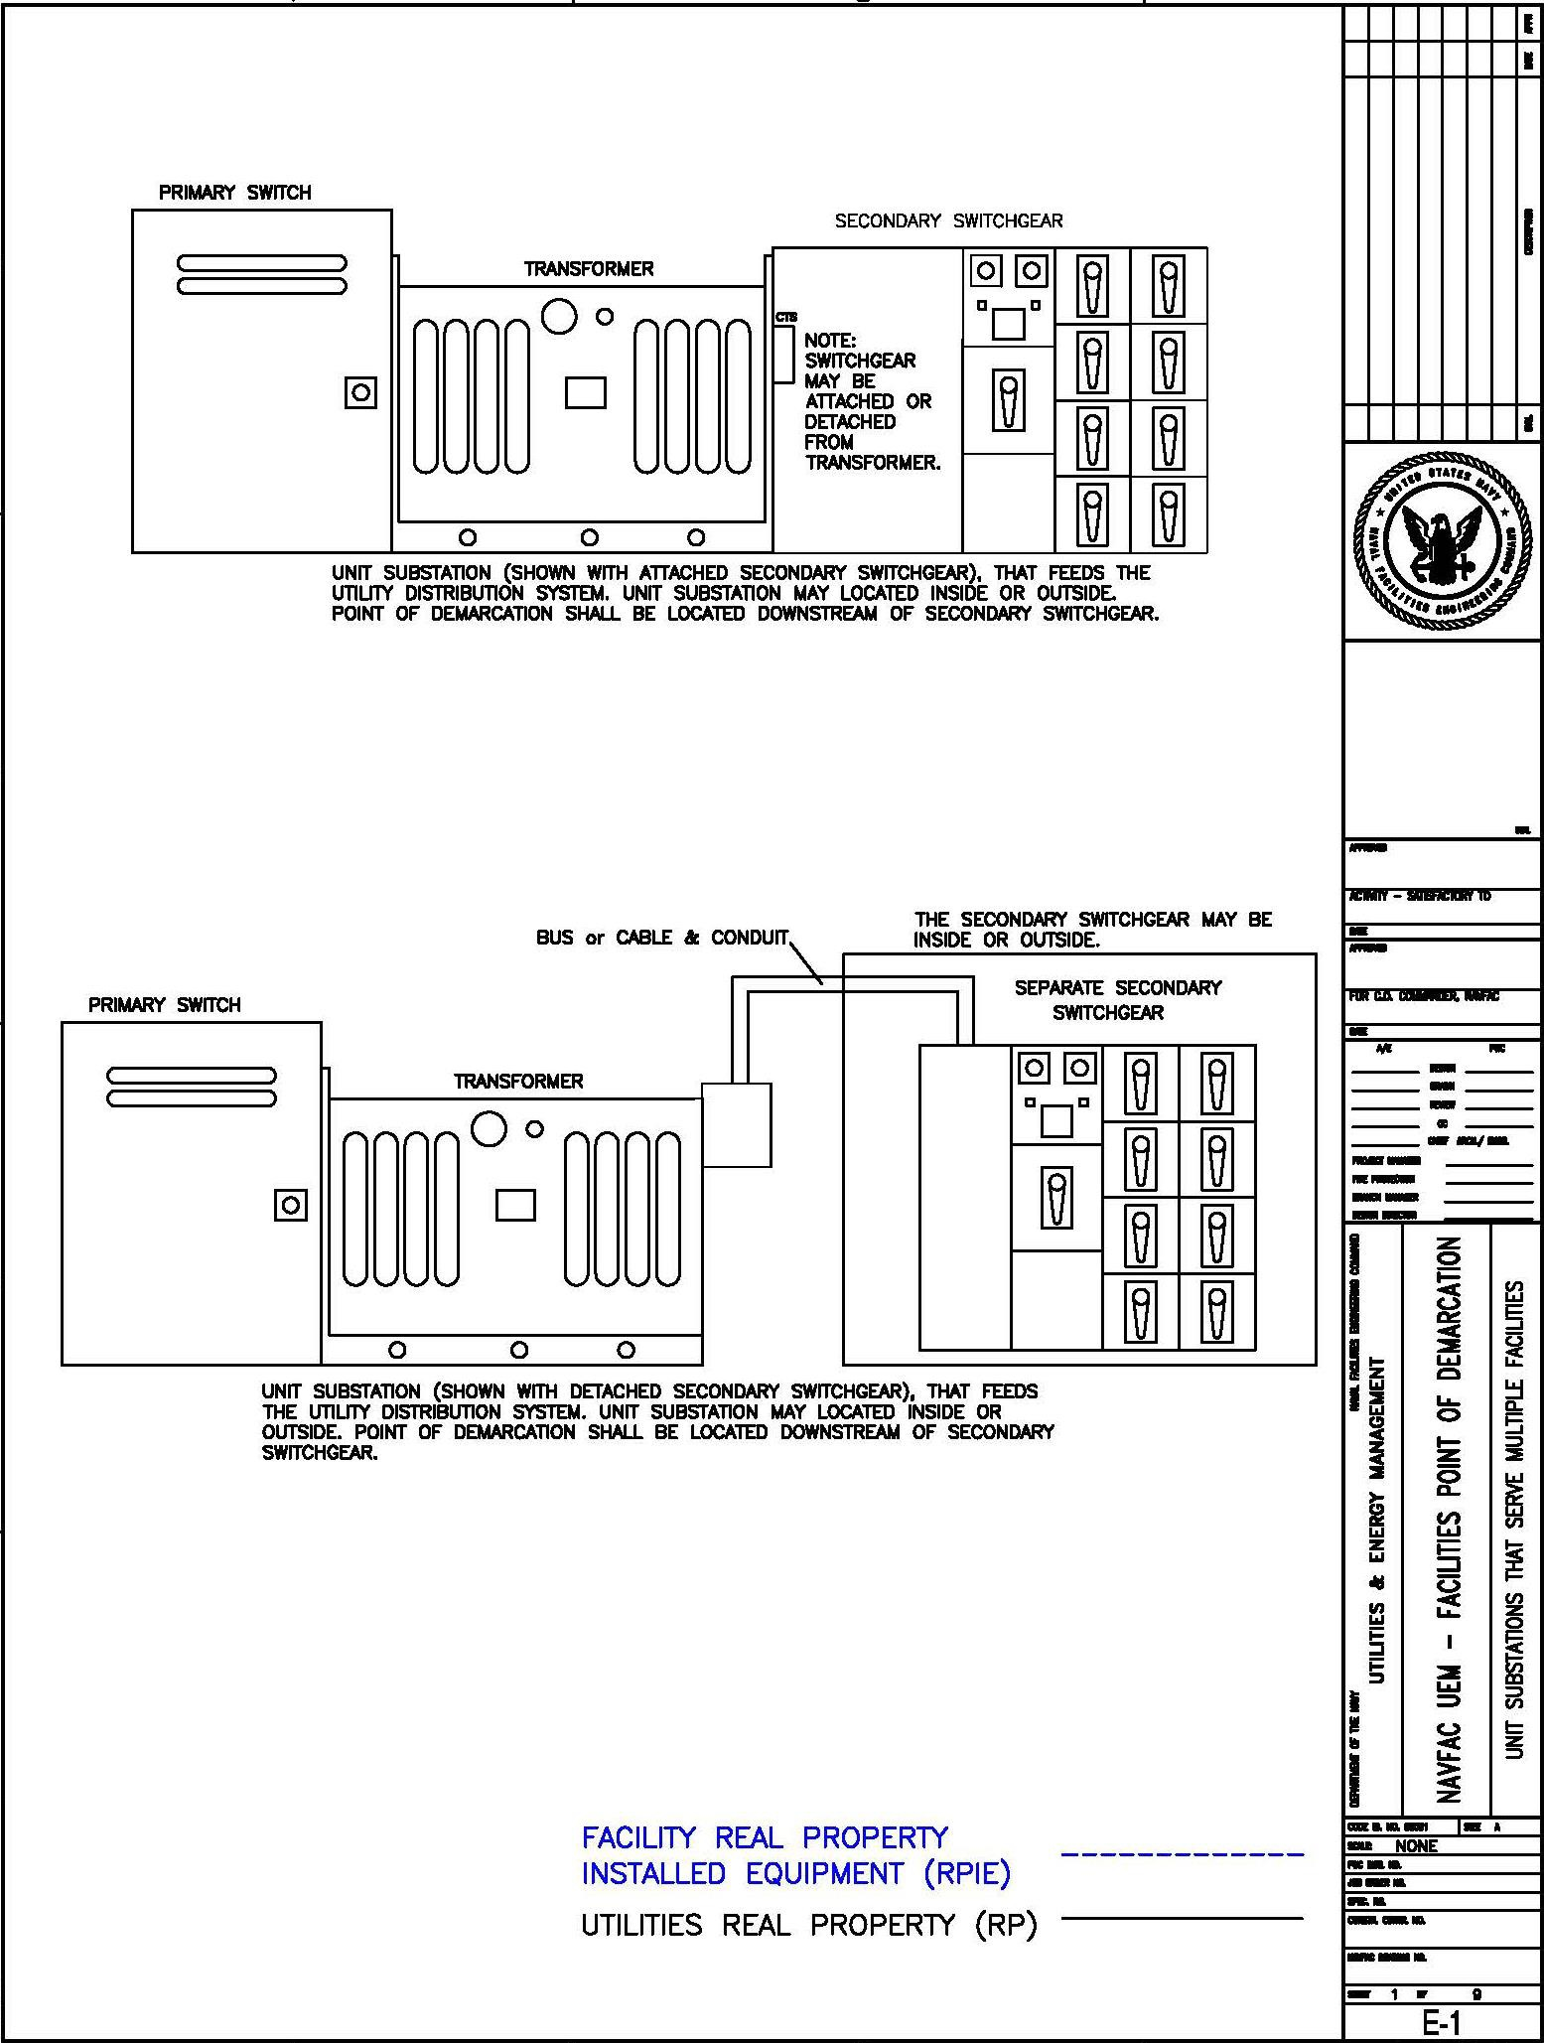

Drawing E-1 – Unit Substations

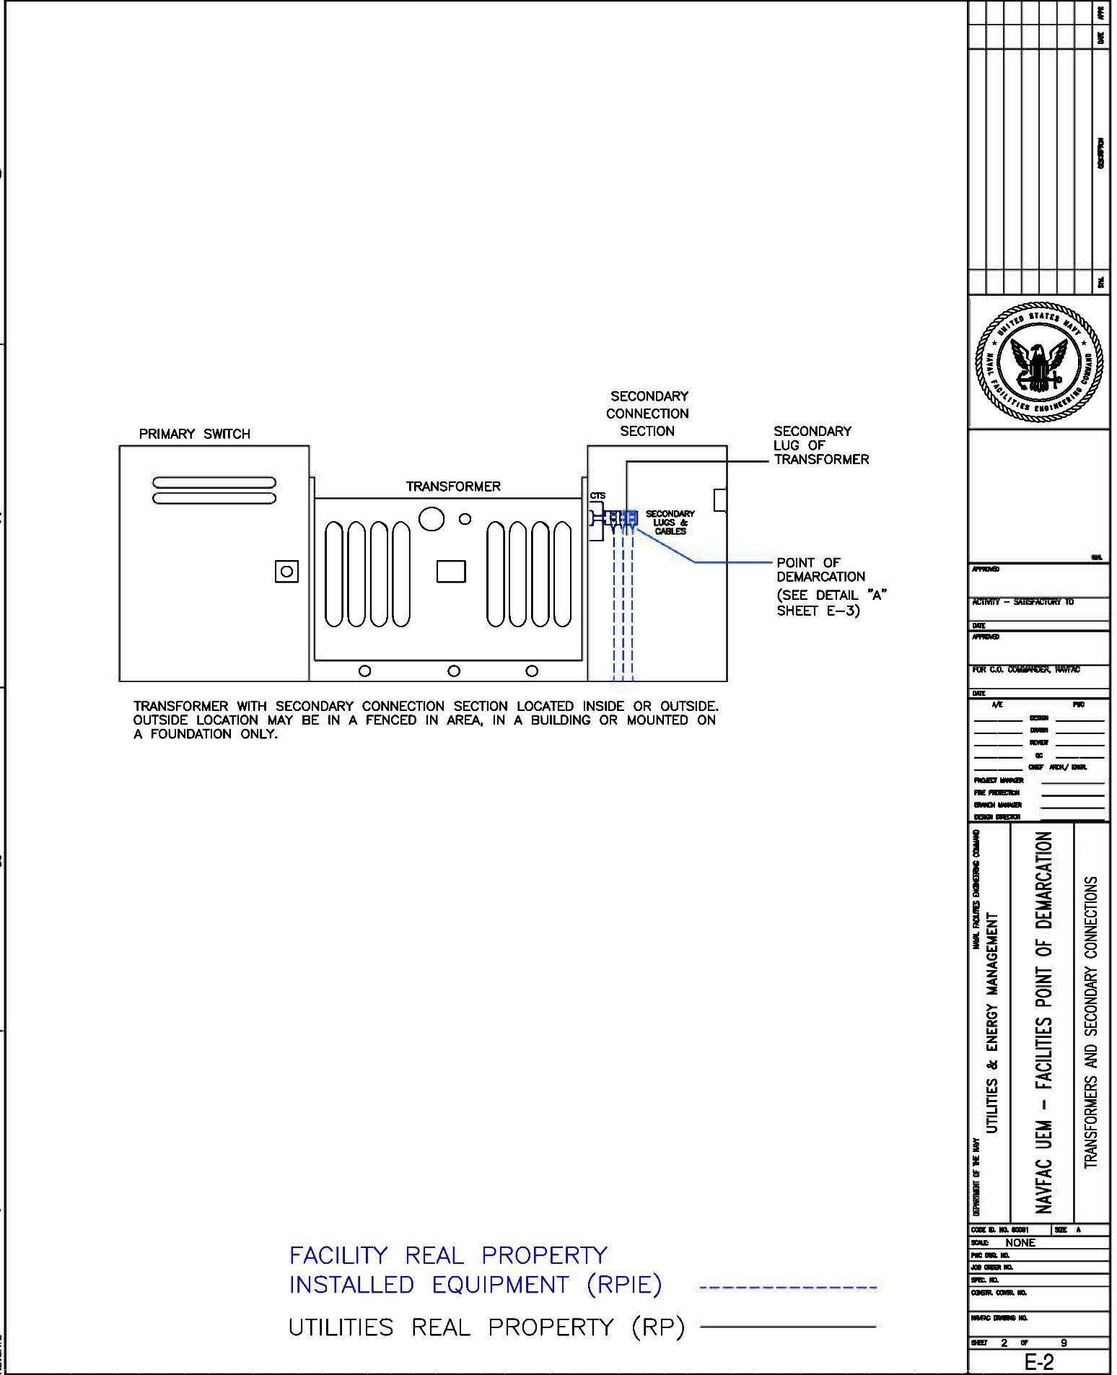

Drawing E-2 – Transformers and Secondary Connections

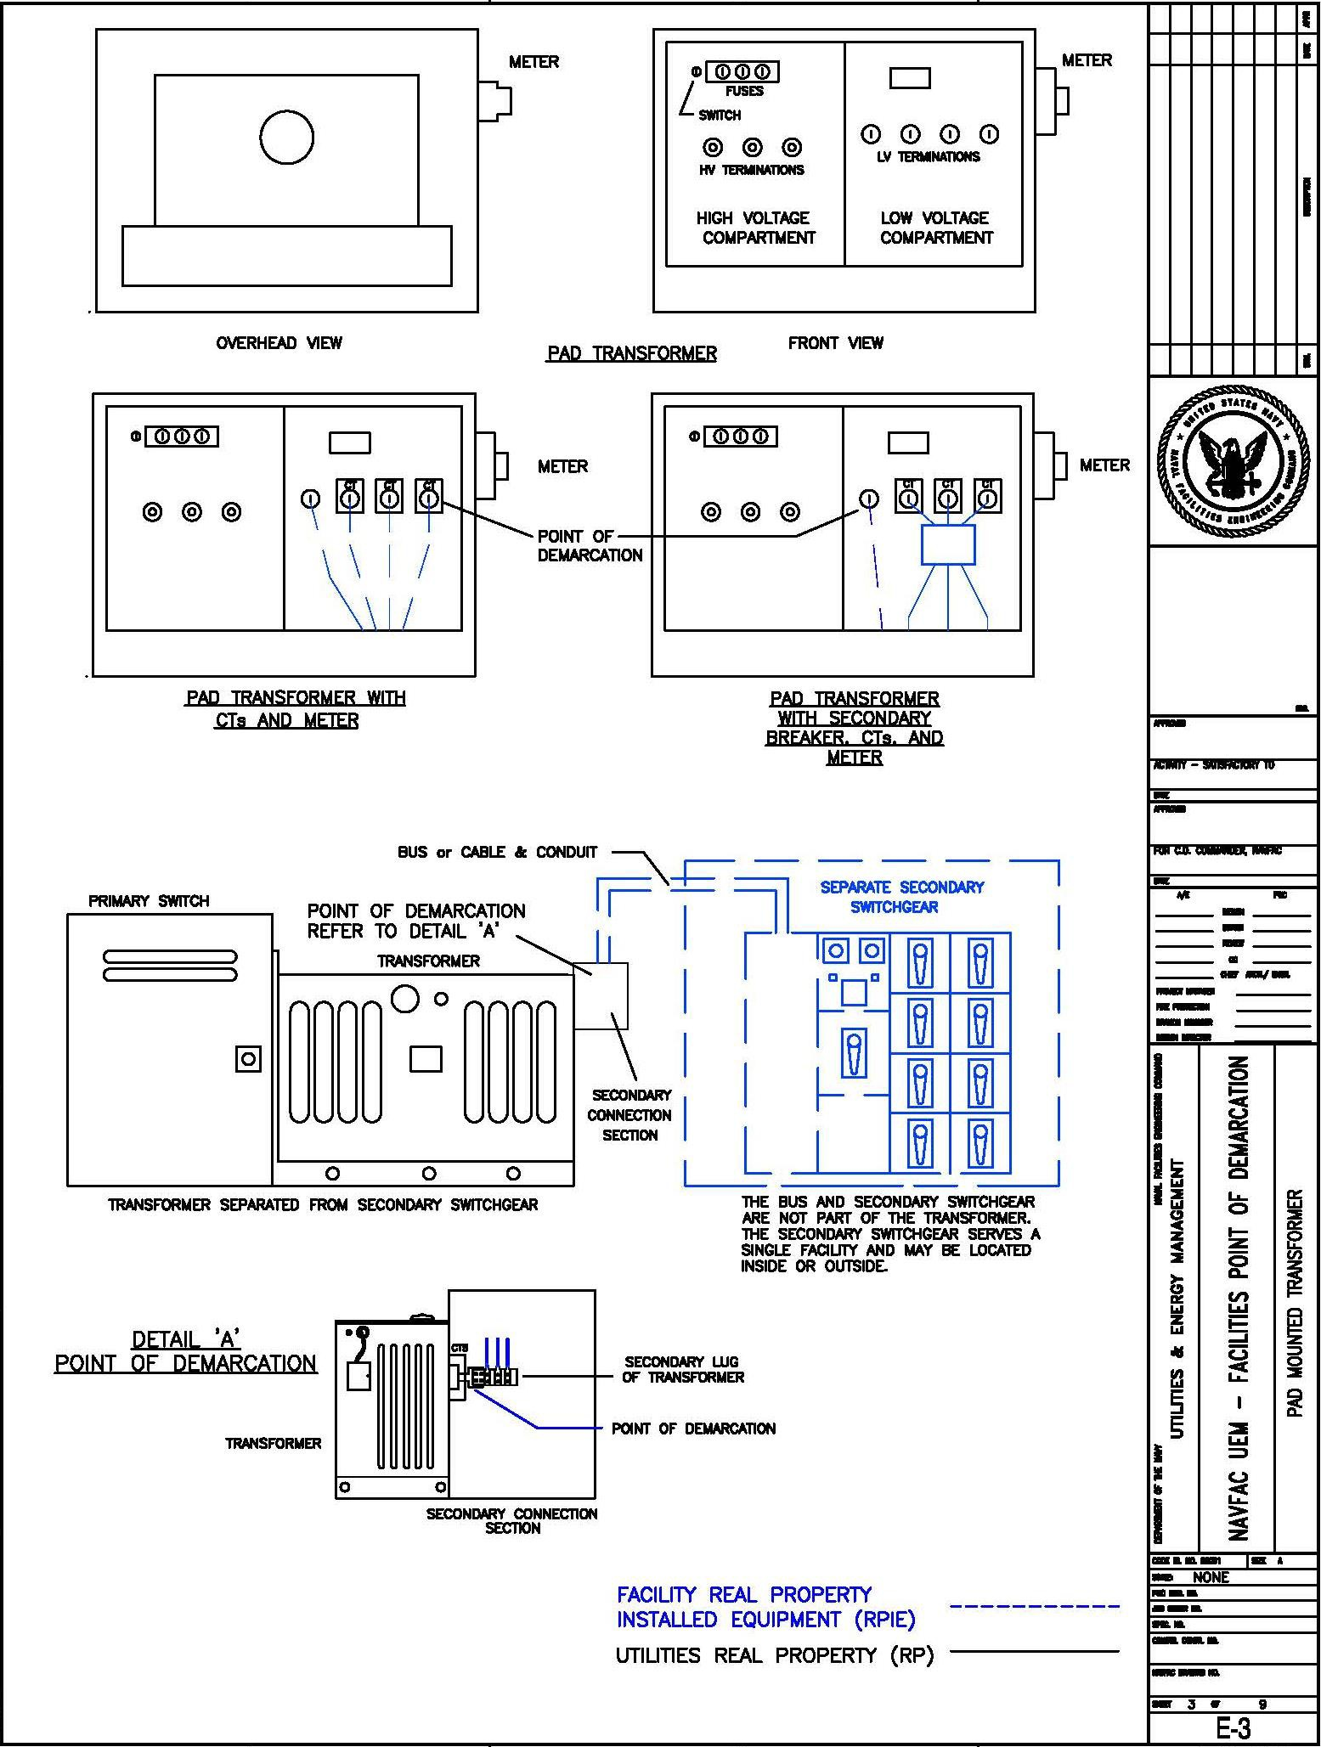

Drawing E-3 – Pad Mounted Transformer

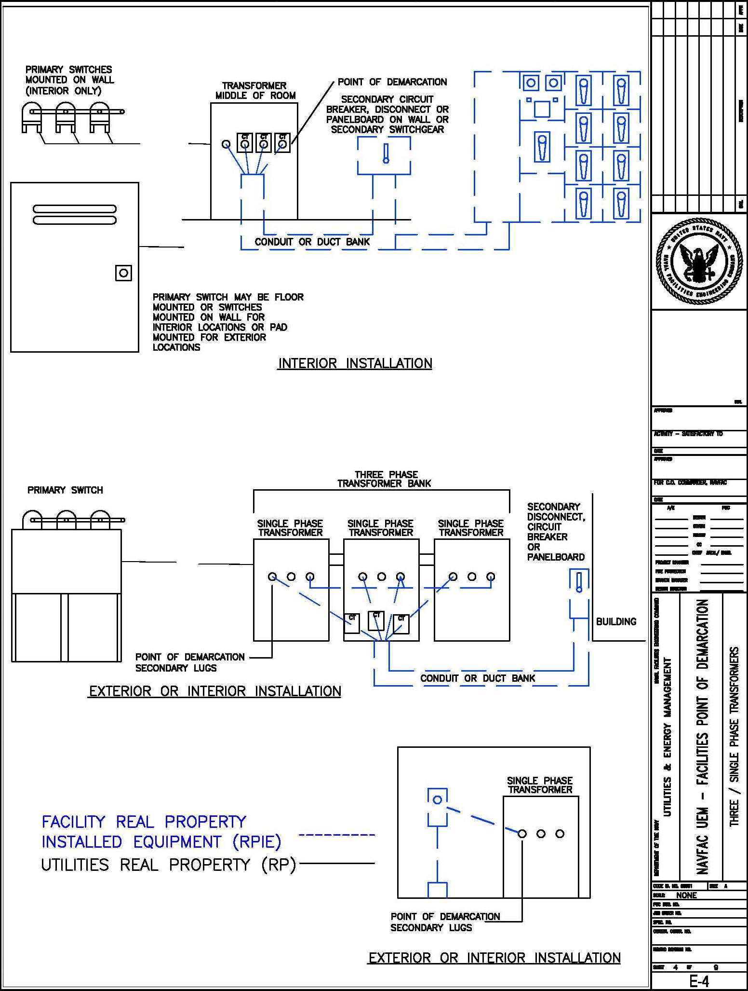

Drawing E-4 – Three/Single Phase Transformers

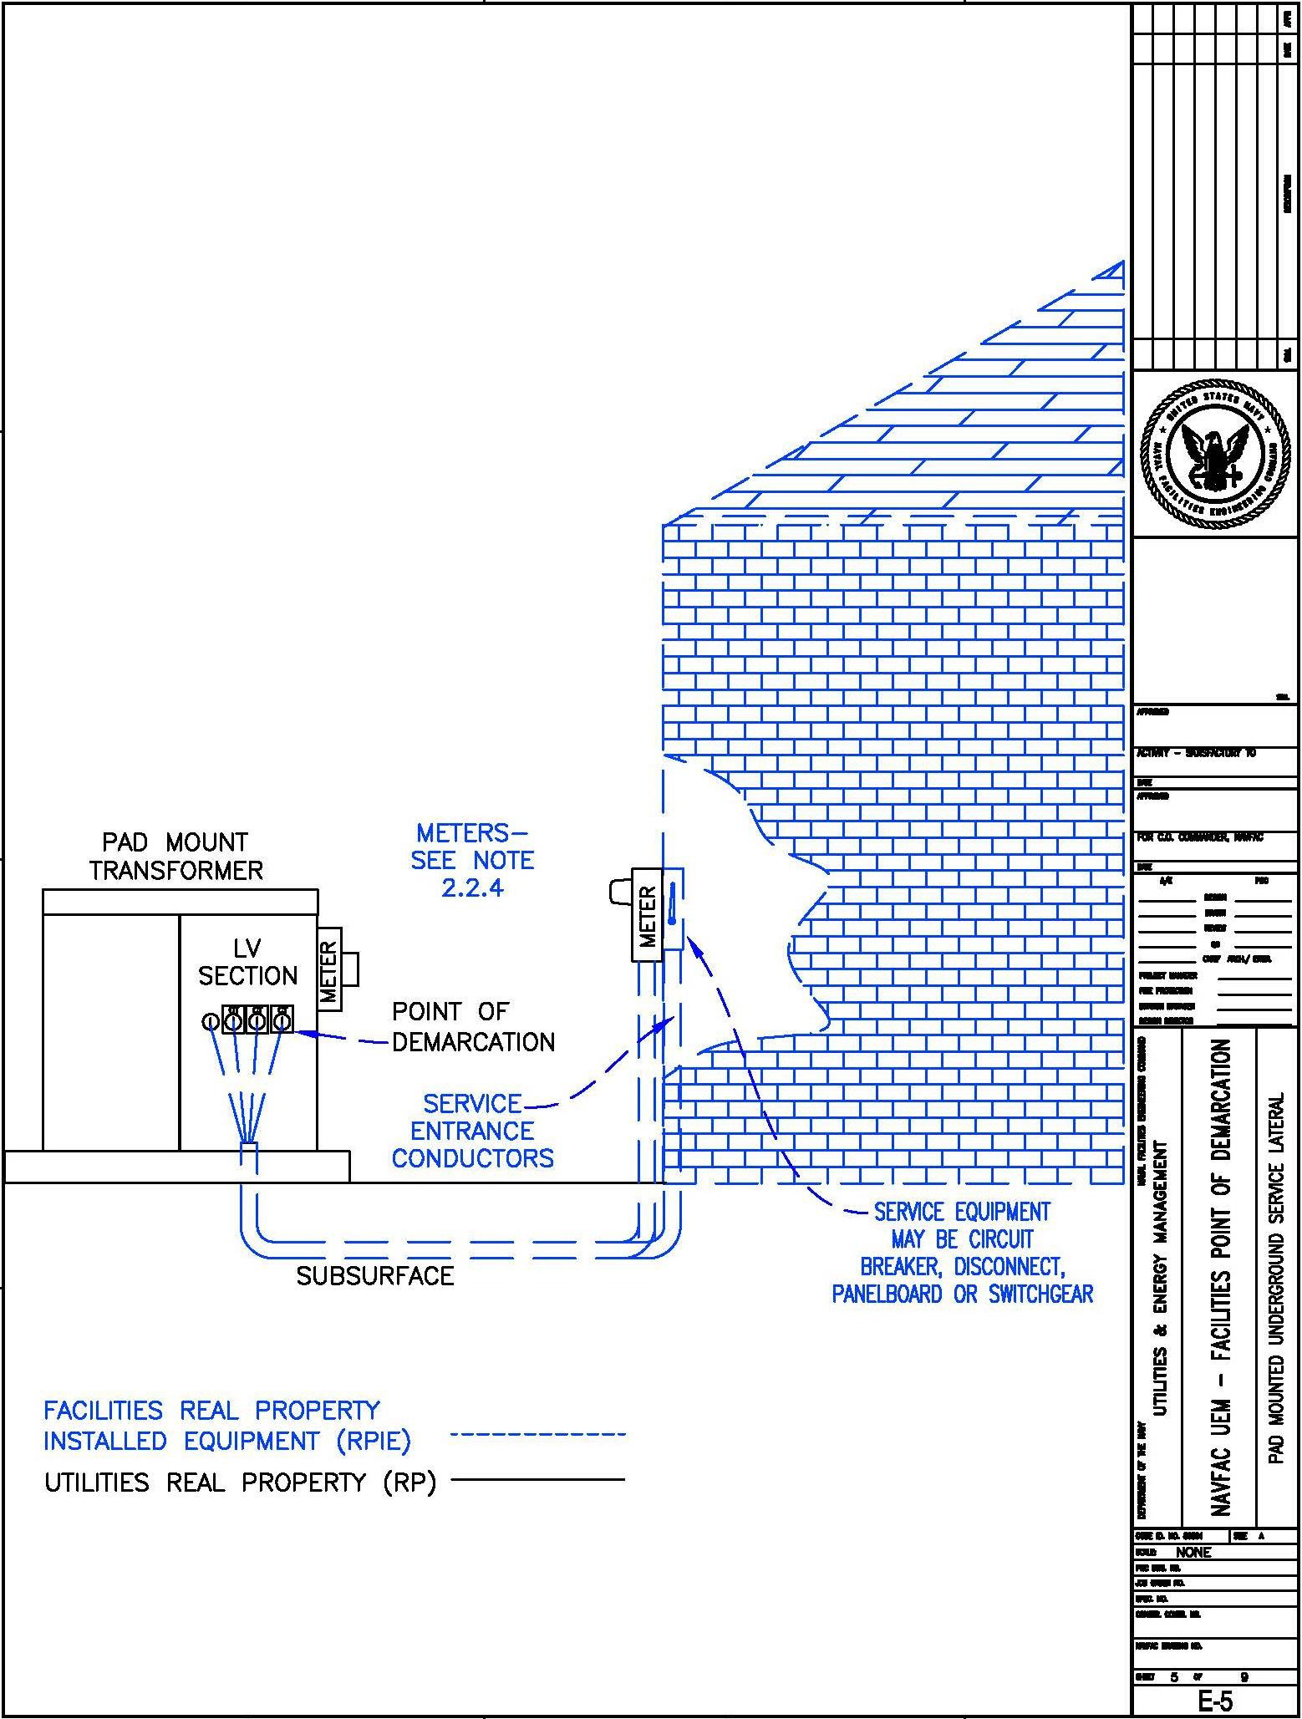

Drawing E-5 – Pad Mounted Underground Service Lateral

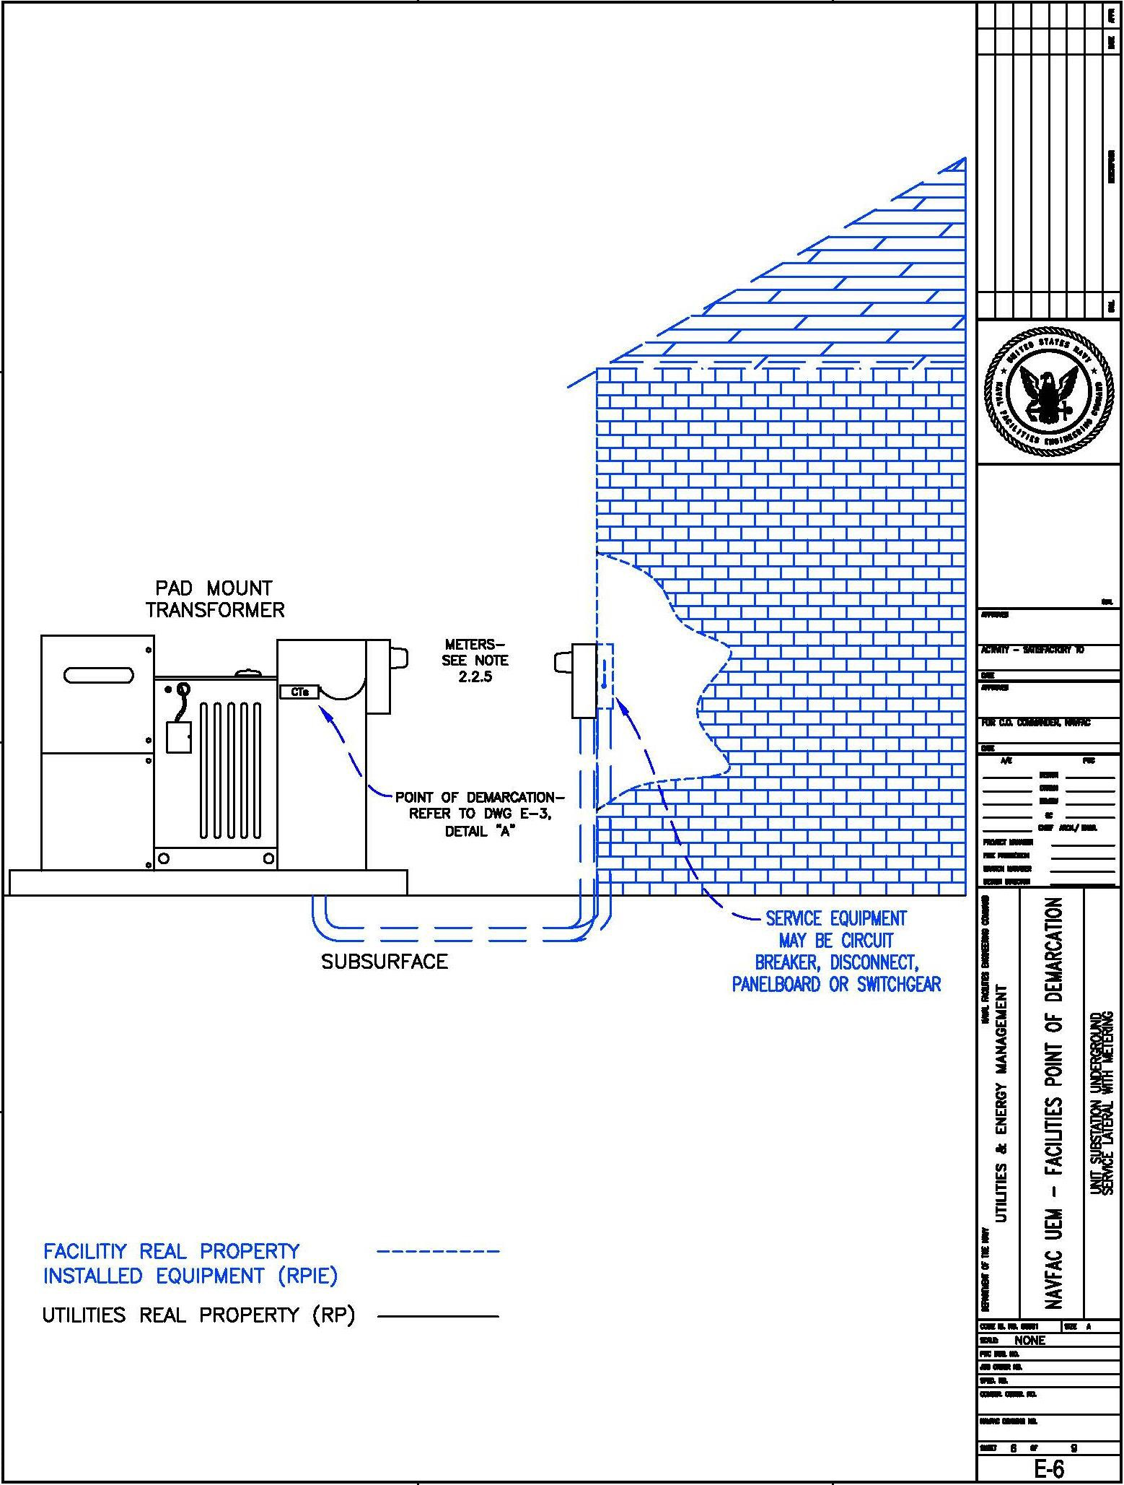

Drawing E-6 – Unit Substation Underground Service Lateral with Metering

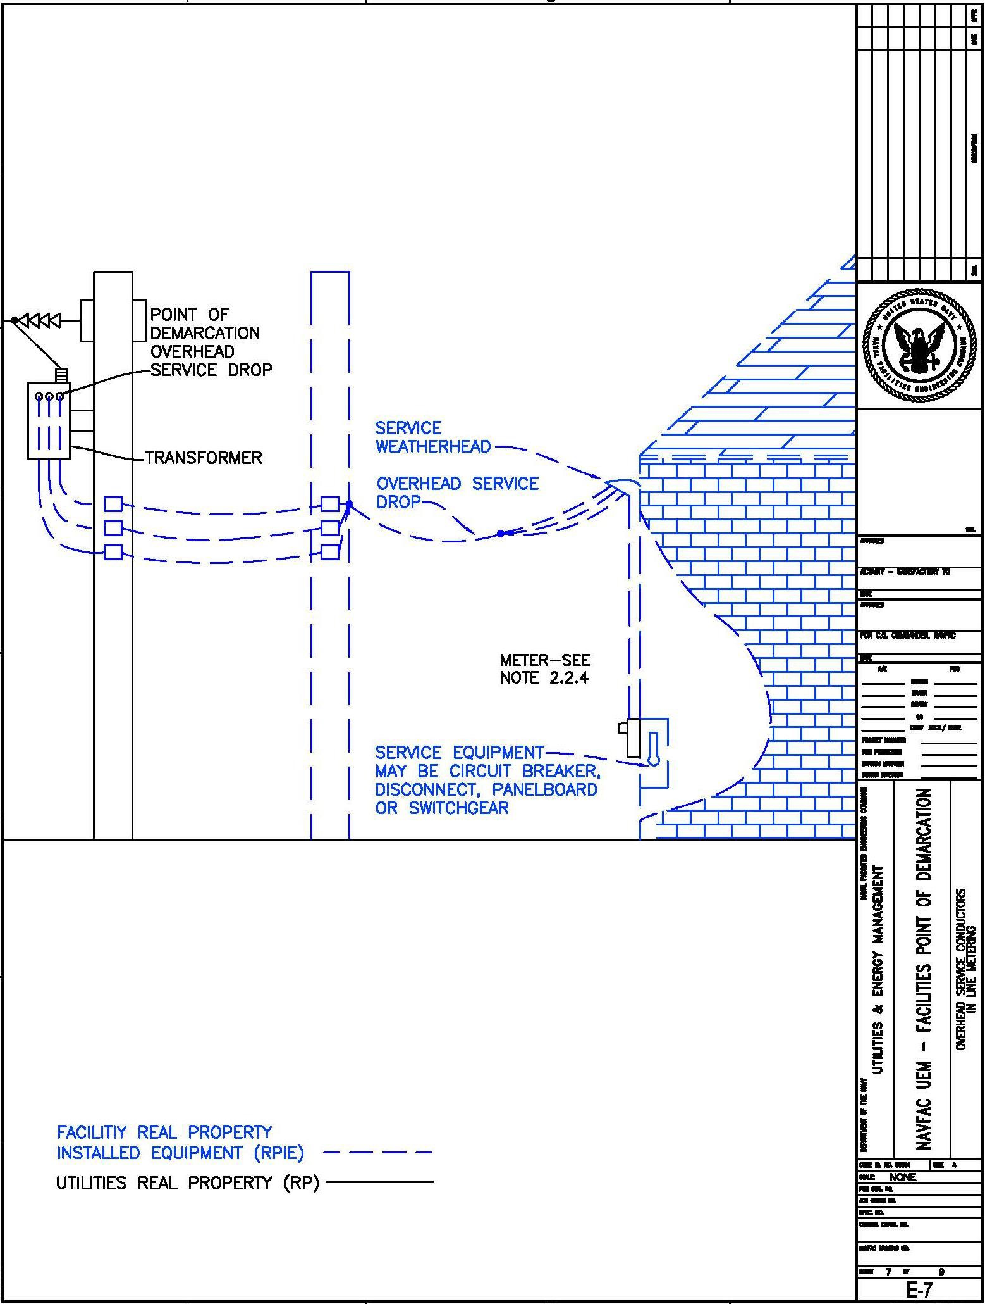

Drawing E-7 - Overhead Service Conductors In Line Metering

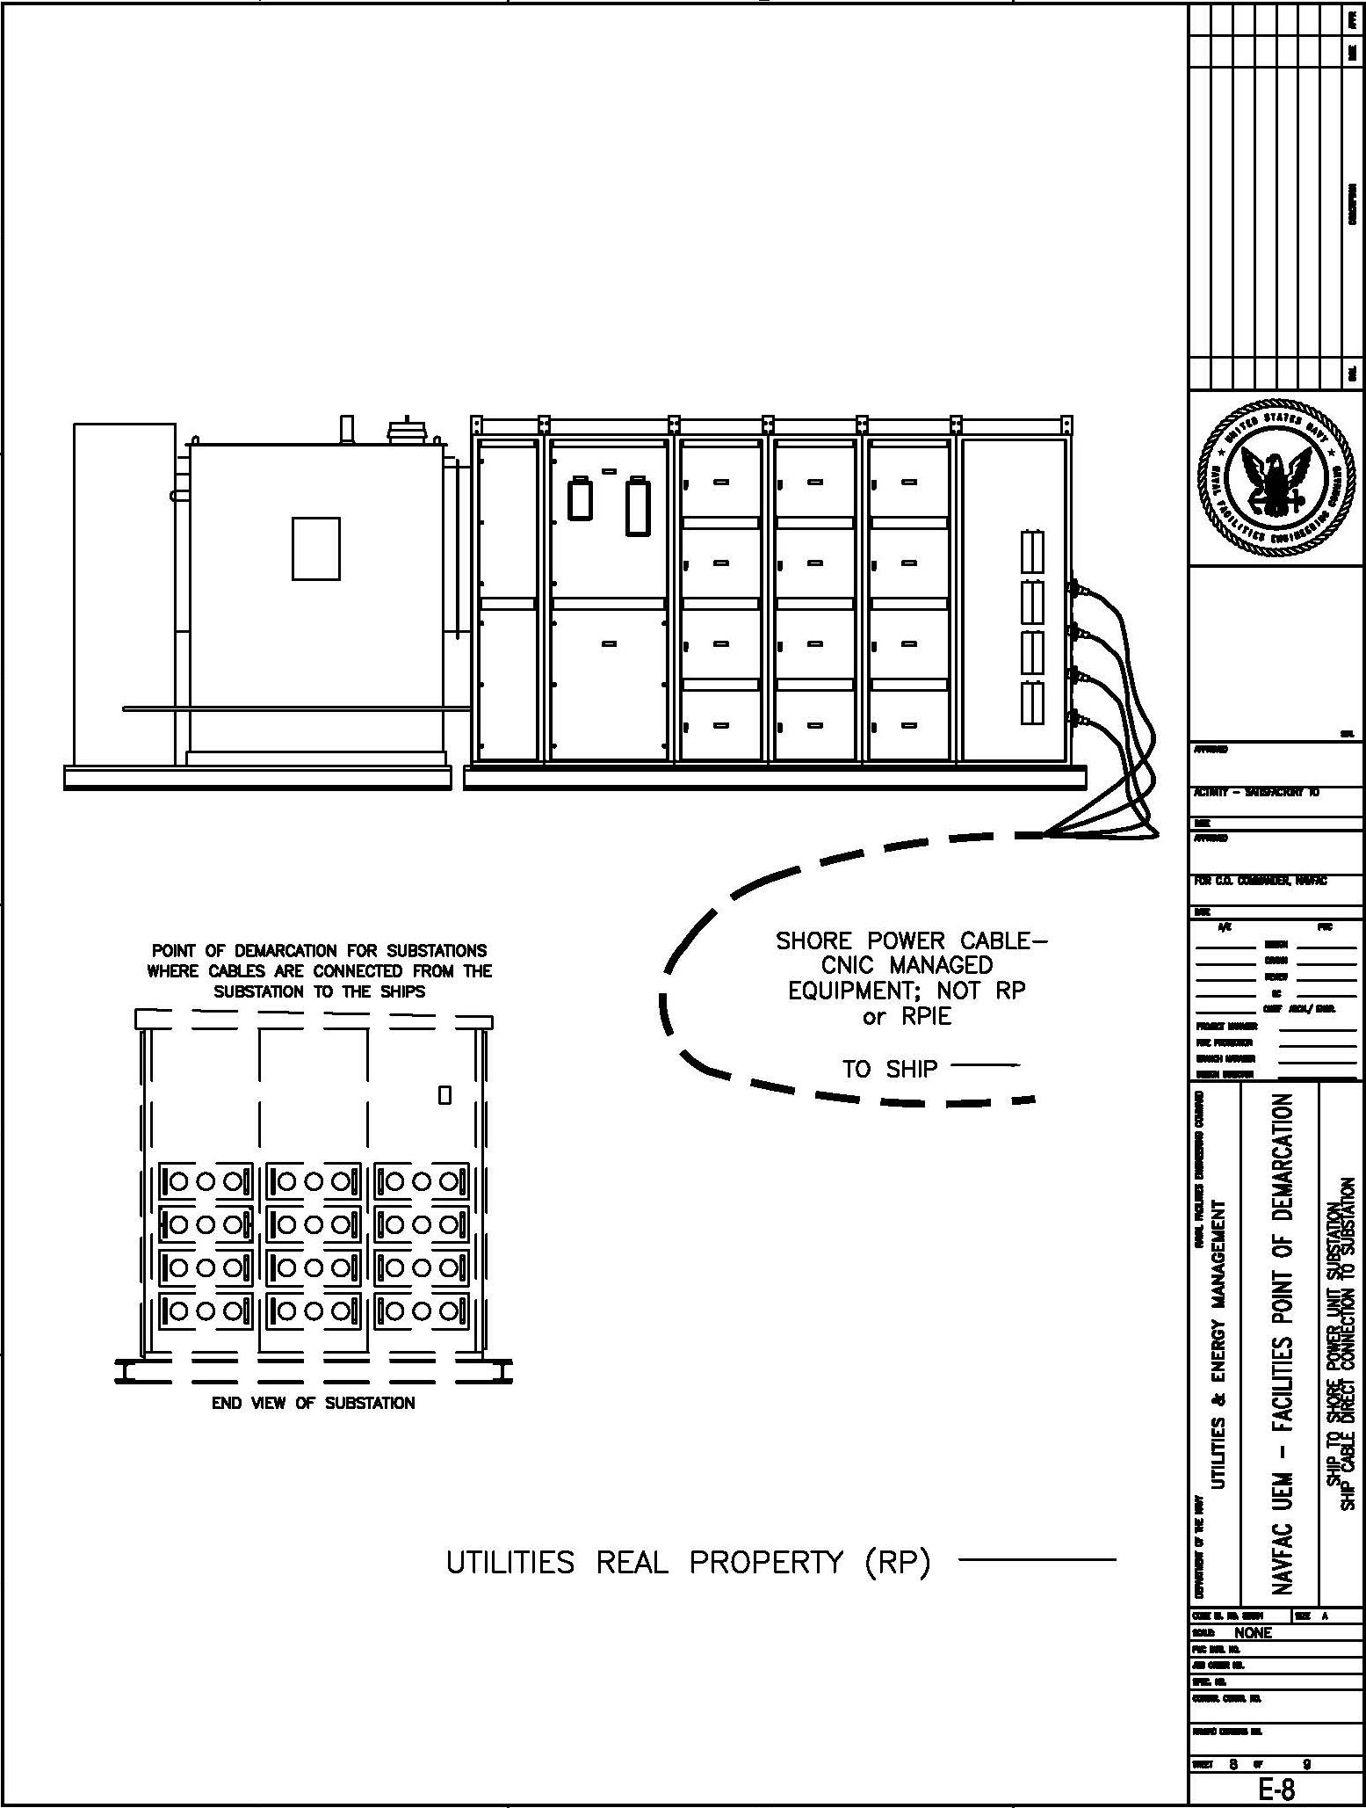

Drawing E-8 – Ship to Shore Power Unit Substation Ship Cable Direct Connection to Substation

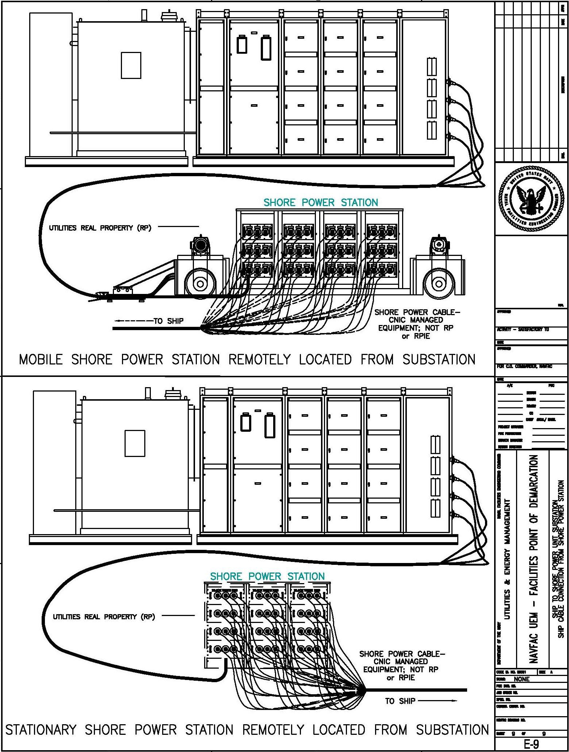

Drawing E-9 – Ship to Shore Power Unit Substation Ship Cable Connection From Shore Power Station

Water System

Water Distribution System and Potable Water (PW) / Irrigation Backflows (W-1)
For all potable water connections, the point of demarcation will be 5 linear feet of pipe from the entry to the facility or structure, unless specified otherwise or by separate Contract (i.e. demarcation points at water utility igloos on the wharves are to the hose connection point for the ships). All related and connected appurtenances upstream of the point of demarcation are considered part of the potable water distribution system and are owned and maintained by the Utility (i.e. fittings, valves, hydrants, PIVs, BFPAs, etc.).

All Backflow Prevention Assemblies (BFPAs) upstream of the point of demarcation will be Utility owned (i.e. 1st BFPA downstream of the main). If the Backflow is downstream of the demarcation point, then the BFPA and 5 linear feet of pipe upstream and downstream will belong to the Utility. The piping between the Utility point of demarcation and the BFPA (and 5 feet upstream/downstream) shall belong to the Facility.

If the BFPA is located within the facility, then access will be granted by the facility to the Utility to inspect and maintain the device as necessary. The intent is for the Utility Contractor to inspect and maintain certified BFPAs, which protect the potable water distribution system from potential cross contamination. This is a regulatory requirement for compliance with the PWD Cross-Connection Control Program (CCCP).

The point of demarcation for irrigation BFPAs will be 5 linear feet of pipe downstream.

The water meter assembly and related appurtenances 5 linear feet of pipe upstream and downstream (i.e. isolation valves, water meter, AMI box/antennae, etc.) are point locations and are owned by the Utility, regardless of location. Some water meters may be located inside a facility or structure.

The Contractor responsible for Operations and Maintenance of the Potable Water Utility shall comply with 62-555 F.A.C. and PWD NS Mayport Cross-Connection Control Program (CCCP) for all applicable assets connected to the potable water system within the points of demarcation for Utilities ownership.

The Utility Contractor shall conduct the inspection of the utility backflows every 5 years to identify and verify inventory and inspection data of current backflow certifications.

Fire Protection Systems and BFPAs (W-2)
For all Fire Protection Systems connected to the potable water system, the point of demarcation will be 5 linear feet of pipe from the entry to the facility or structure (see information below for leased facilities).

BFPAs upstream of the point of demarcation are Utility owned. BFPAs downstream of the point of demarcation (if they are the 1st BFPA downstream of the potable water main) will also be Utility owned and will include 5 linear feet of pipe upstream and downstream (regardless if located inside a facility). The piping between the Utility point of demarcation and the BFPA (and 5 feet upstream/downstream) shall belong to the Facility.

For stand-alone fire protection systems, fire water storage tanks and associated downstream fire protection systems fed from the potable water distribution system, the Utility Contractor will own the 1st BFPA or air gap prior to the fire systems storage tanks. The downstream tanks and fire systems are not Utility assets (Facility owned).

Government-furnished Facilities or Leased Facilities and BFPAs (W-3)
If the occupant leasing or occupying the facility owns the 1st BFPA on the fire protection supply line downstream of the potable water main, then the occupant shall be responsible for inspection/testing/certification of the 1st BFPA. The Utility owns the potable water distribution system upstream of the 1st Fire BFPA owned by the occupant. The occupant of the facility shall be responsible for complying with State of Florida FDEP (Florida Department of Environmental Protection) Testing and Reporting which requires providing physical legible weather-proof tagging at the Assembly, maintaining certification records for a minimum of five (5) years, and annually reporting certification records for the BFPA on the fire system to the Utility Contractor responsible for Operations and Maintenance of the Potable Water Utility. The 1st potable water BFPAs and irrigation system BFPAs are owned and maintained by the Utility in Government leased facilities.

The inspection, testing, and certification of occupant owned fire flow BFPAs shall take place in the presence of the appropriate Water Utility Contractor personnel for verification with the occupant of the facility. It shall be the responsibility of the occupant of the Government furnished/leased facility (if the BFPA is owned by the occupant) to provide annual reporting of BFPA certifications to the Water Utility Contractor no later than 1 February of the following calendar year.

The occupant of the facility will conduct an internal BFPA inspection of the facility every 5 years to identify all backflows related to the facility and report the results of the inspection to the Utility Contractor as required by FDEP regulations.

Examples of Points of Demarcation, unless an exception is provided elsewhere by contract:

- Bennett Shores Neighborhoods (East and West): The demarcation point of the water distribution system is 5 linear feet of pipe from the facility or residence.
- Ribault Bay and NEX/Commissary/CDC (outlying locations): The demarcation point for the Utility system begins at the downstream side of the master meter owned by the City of Atlantic Beach. The downstream demarcation point of the water distribution system for Ribault Bay residences is 5 linear feet of pipe from the facility or residence. The Government owns the water utility system (water lines, valves, and fire hydrants and other components) at the outlying locations for CDC/Ribault Bay/NEX/Commissary.
- Heckscher Drive Navy Fuel Depot (outlying location): The demarcation point is the downstream side of the main water meter owned by the City of Jacksonville, JEA. The main water meter and two back flow preventers (at Heckscher Drive roadway) are the property of JEA. After the JEA owned Backflow preventers and water meter at Heckscher Drive, the 4” water main and all downstream potable water system assets are owned by the Navy. The points of demarcation for the facilities and structures are the same as the NS Mayport installation (Main Base).

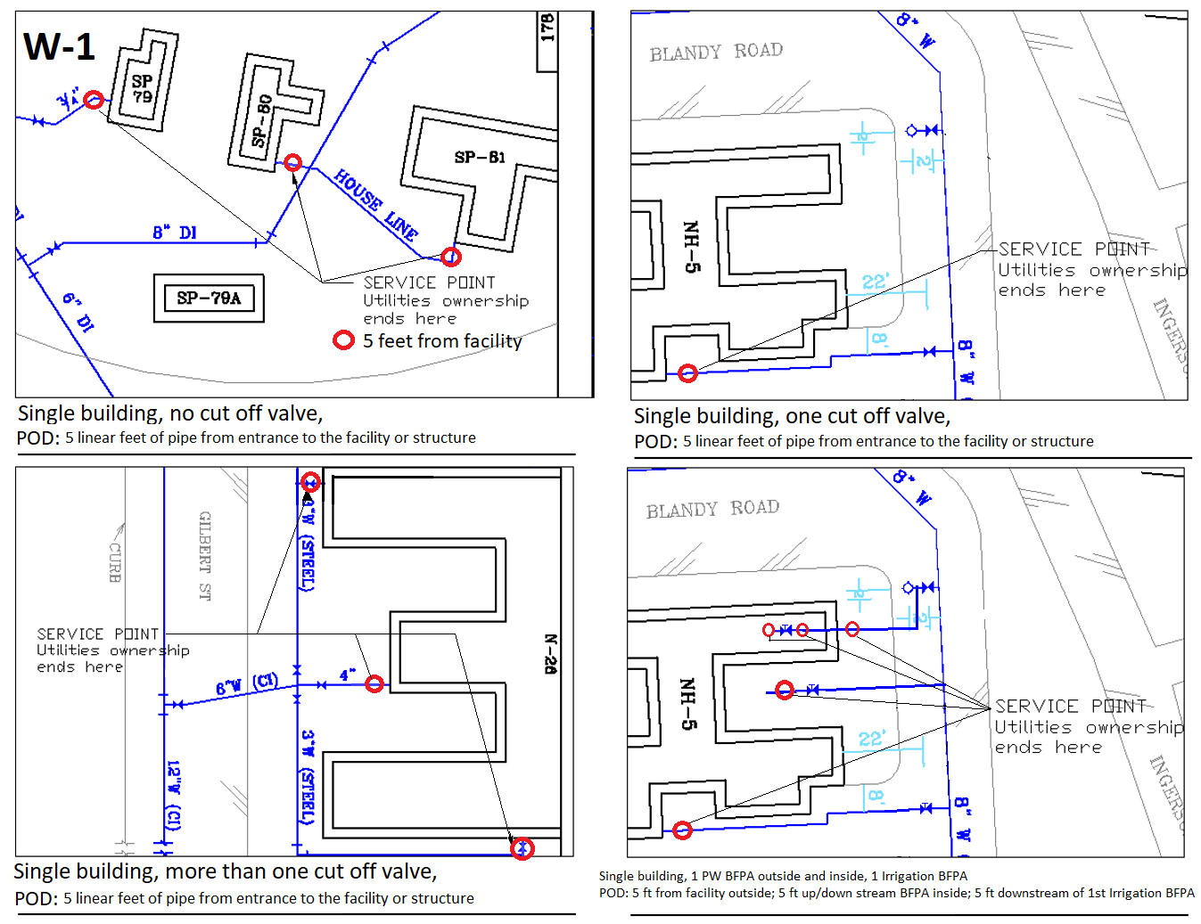

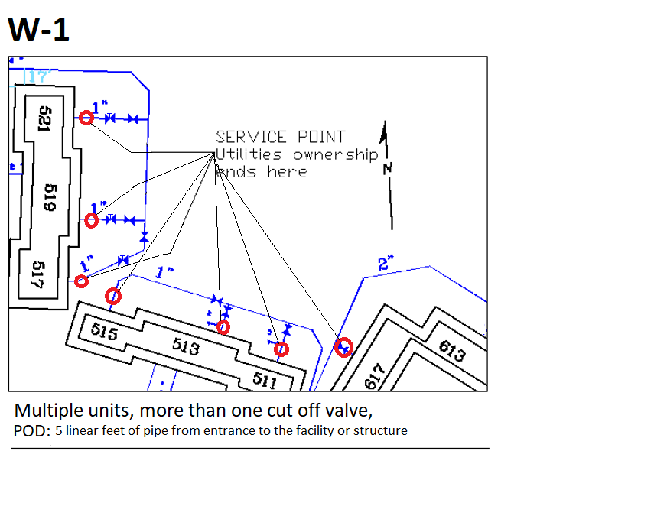

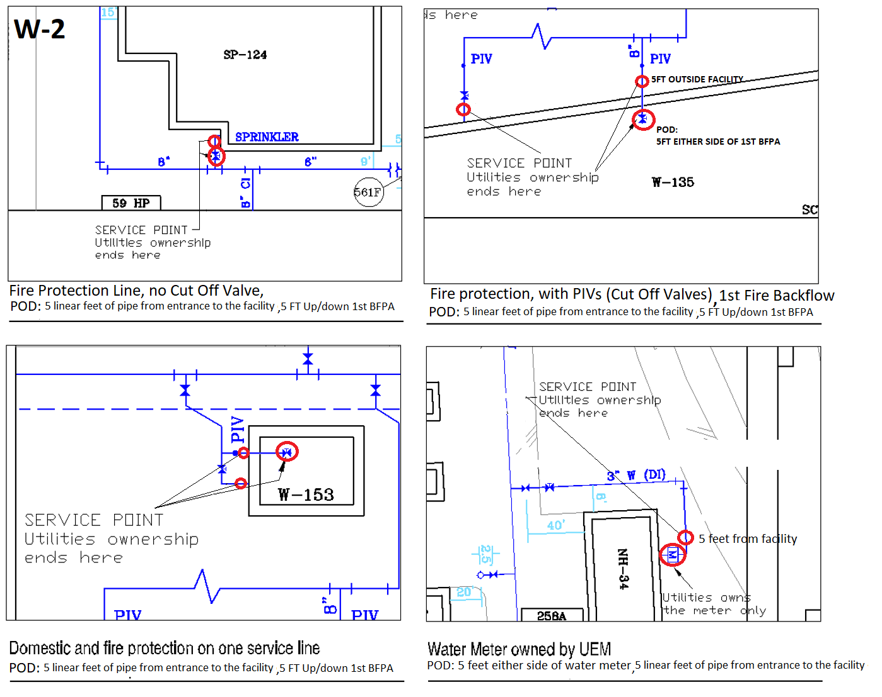

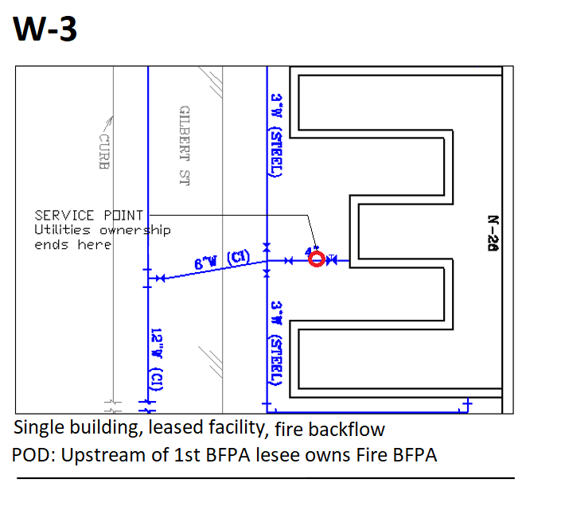
Wastewater System
Definitions
Building Activity – The command/activity having financial responsibility for a building or Customer Facility.
Customer Facility – A facility owned and maintained by the customer served by the wastewater System Owner.
Lateral – The line that extends from the building to either the main sewer line, a manhole located on the main sewer line, or a pump station. Cleanouts are considered a component of the Lateral.
Main Sewer Line – Sewer lines from the point of connection to a commercial wastewater system or System Owner wastewater treatment facility, to the furthest upstream manhole.
Manhole – A structure, which is all or partially underground, and is accessible to entry. The structure is designed to collect sewage from underground piping by means of gravity flow or pumping, and discharge by means of gravity.
Oil-Water Separator – A structure/tank, which is underground, partially underground, or above ground and is accessible to entry. The structure is designed to collect, separate and/or hold oil from an oil-water mixture waste stream.
Pump Station – A structure designed to receive, hold, and discharge sewage. Discharge of sewage is accomplished by pumping through underground piping (force main) to a manhole where gravity flow occurs.
Wash Rack – A structure designed for the washing and rinsing of vehicles, aircraft and equipment.
Diversion Valve – A valve intended to divert effluent between a wastewater system and storm drainage system.
Service Point – The service point is the point of connection between the serving utility and the Customer Facility and is also the “Point of Demarcation” where ownership changes. Refer to drawings on pages 3-4.
System Owner (SO) – The servicing utility company that owns and operates the wastewater system.
Wastewater Treatment Plant – A facility where wastewater is treated with chemical or biological processes to produce clean water that can be returned to rivers and waterways.
Points of Demarcation (Service Points)
Gravity Lines, Manholes, and Force Mains – The Point of Demarcation is the upstream side of the cleanout closest to the building. If no cleanout exists, POD is 5’ from face of the building.
Storm Drainage Systems – Combined wastewater and storm drainage systems are not allowed. Separation of connections between wastewater and storm drainage systems are the responsibility of the system owner making the unauthorized connection.
Cesspools, Holding Tanks, and Septic Tanks – Cesspools, Holding Tanks, and Septic tanks with or without leaching fields, are the responsibility of the Customer Facility and cannot be connected to the main sewer line directly or via laterals except where the leaching field is connected to a permitted treatment process.
Cleanouts – Installation and Maintenance of cleanouts are the responsibility of the SO. For each connection to the Main Sewer Line, a sewer cleanout is required.
Wastewater Pump Stations – The SO is responsible for all pump stations on the main sewer line and serving any facilities.All other pumps stations are the responsibility of the Customer Facility. Lift Station 2229 at Building 1552 will remain a government asset.
Piers and Dry Docks – The Point of Demarcation is the at the pier riser at the hose connection point.
Wash Racks – Wash racks are the responsibility of the Customer Facility.
Oil-Water Separators – Oil-water separators (OWS) exterior to a building are the responsibility of the SO. Any lines or manhole upstream of an OWS are considered part of the Customer Facility.
Grease Interceptors – Grease Interceptors (GI), also called Grease Traps, are the responsibility of the Customer Facility that the GI serves. Any lines or Manholes upstream of the GI are considered part of the Customer Facility.
Diversion valve – The diversion valve or any structure upstream of this valve are the responsibility of the Customer Facility.
Wastewater Treatment Plants – Wastewater Treatment Plants that receive wastewater from a collection system serving multiple facilities are part of the SO-owned system. Wastewater Treatment Plants that serve a single Customer Facility are not part of the SO-owned system.
Drawings of Wastewater System Service Points – Drawings depicting examples of Service Points can be found in the following drawings.

